GCh Whitfield BluVus Quicksilver ECM CD RN CGC  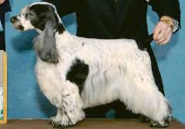 | Ch Whitfield Windover’s Nova | Ch Coventry Whitfield Vindicator | Ch Whitfield’s Crescent Moon ECM WD CGC | Ch Craigleith Man of Magic
 |  |  |  | Ch Gandy Dancer’s Can Dew II ECM
 | Ch Whitfield Windover’s Nova | Ch Coventry Whitfield Vindicator | Ch Headwind’s Kittyhawk ECM | Ch Ashgrove Headwind’s Nighthawk
 |  |  |  | Ch Capercaille Penny Arcade
 | Ch Whitfield Windover’s Nova | Ch Windover Whitfield’s Luna | Ch Whitfield’s Crescent Moon ECM WD CGC | Ch Craigleith Man of Magic
 |  |  |  | Ch Gandy Dancer’s Can Dew II ECM
 | Ch Whitfield Windover’s Nova | Ch Windover Whitfield’s Luna | Whitfield’s I’m the One | Ch BluVu Whitfield’s Knockout
 |  |  |  | Ch Whitfield’s Blue Dawn
 | Craigleith New Moon | Craigleith Student Prince | Lynwater Islander | Lynwater Isleman
 |  |  |  | Ch Lynwater Dawn Shimmer
 | Craigleith New Moon | Craigleith Student Prince | Craigleith The Last Waltz | Lochdene Orpheus at Sorbrook
 |  |  |  | Craigleith Merry Widow Waltz
 | Craigleith New Moon | Scomar Sun Maiden at Craigleith | Craigleith A Step in Time | Prince Igor of Craigleith
 |  |  |  | Craigleith The Snow Maiden
 | Craigleith New Moon | Scomar Sun Maiden at Craigleith | Trimein Colour Me in at Scomar | Lynwater Flute
 |  |  |  | Trimein First Edition
Ch Ainsley’s Penthouse Sweet  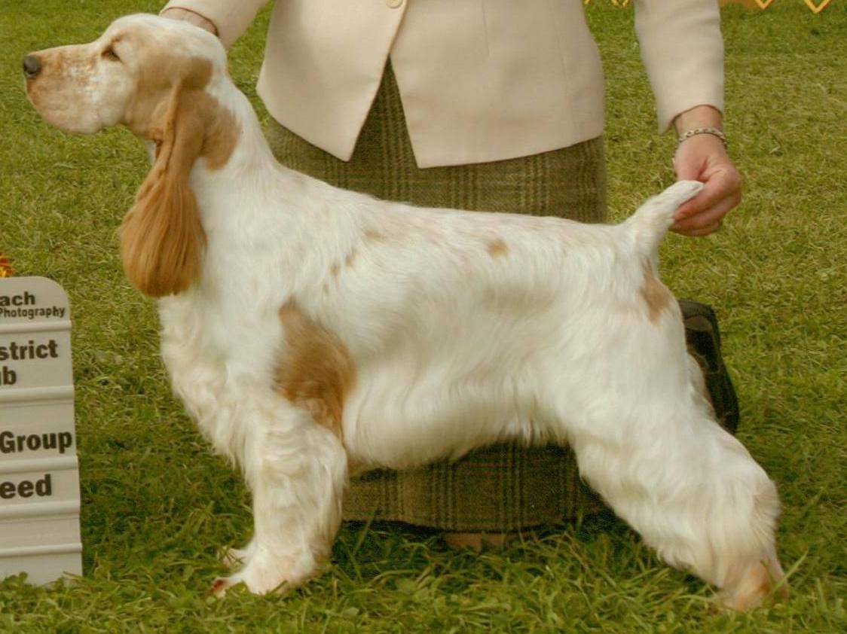 | Ch Brasswind’s Ego Trip ECM | Ch Ashbrook Aristocrat ECM | Ch Lynann’s Telesis ECM | Ch Carachelle Centurion ECM
 |  |  |  | Ch Lynann’s Precious Image ECM
 | Ch Brasswind’s Ego Trip ECM | Ch Ashbrook Aristocrat ECM | Ch Headwinds Kittyhawk ECM | Ch Ashgrove Headwinds Nighthawk
 |  |  |  | Capercallie Penny Arcade
 | Ch Brasswind’s Ego Trip ECM | Ch Brasswinds Blueberry Bash ECM | Ch Lynann’s Infiniti ECM | Ch Lynann’s Never Ending Story ECM
 |  |  |  | Ch Cambridge Lynann Doves Cry
 | Ch Brasswind’s Ego Trip ECM | Ch Brasswinds Blueberry Bash ECM | Ch Gentree Blueberry Muffin ECM | Ch Kvammes Hollywood TD
 |  |  |  | Ch Gentree Midnight Lace
 | Ch Ainsley’s The One’s One | Am/Can Ch Ainsley’s Johnny Bravo ECM | Ch Daisymead’s Playboy ECM | Ch Daisymead’s Birth of the Blues ECM
 |  |  |  | Daisymead’s Main Squeeze
 | Ch Ainsley’s The One’s One | Am/Can Ch Ainsley’s Johnny Bravo ECM | Ch Faerytail’s Leprechaun | Ch Ashbrook Aristocrat ECM
 |  |  |  | Ch Royal Crest Dreamcatcher WDX ECM
 | Ch Ainsley’s The One’s One | Ainsley’s Jazzy Blue Bonnet | Boxhill Bombardier | Ch Ainsley Boxhill Back N Black
 |  |  |  | Boxhill Body Double
 | Ch Ainsley’s The One’s One | Ainsley’s Jazzy Blue Bonnet | Ch Ainsley’s Krime of Passion | Ch Ainsley’s Taylor McMurphy
 |  |  |  | Ch Portrait Ainsley Blu Lace

